An Adaptive Modulation For Free Space Optical (FSO) Systems

Report submitted to GITAM (Deemed to be University) as a partial fulfillment of the requirements for the award of the Degree of Bachelor of Technology in (write your respective branch)
DEPARTMENT OF ELECTRICAL, ELECTRONICS AND COMMUNICATION ENGINEERING
GITAM SCHOOL OF TECHNOLOGY
GITAM (DEEMED TO BE UNIVERSITY)
BENGALURU -561203
NOV 2025

Name:1)Hari Pawar (BU22EECE0100462)
2)Saiprajwalreddy (BU22EECE0100437)
3)Laxmiprasad Sindageri (BU22EECE0100451)

DECLARATION

I/We declare that the project work contained in this report is original and it has been done by me under the guidance of my project guide.

Name:

1)Hari Pawar
2)Saiprajwalreddy
3)Laxmiprasad Sindageri

Date: Signature of the Student

Department of Electrical, Electronics and Communication Engineering GITAM School of Technology, Bengaluru-561203



CERTIFICATE

This is to certify that (Laxmiprasad S)(Saiprajwalreddy)(Hari Pawar) bearing (Regd. No.:BU22EECE0100451,437,462) has satisfactorily completed Mini Project Entitled in partial fulfillment of the requirements as prescribed by University for VIIth semester, Bachelor of Technology in “Electrical, Electronics and Communication Engineering” and submitted this report during the academic year 2025-2026.

[Signature of the Guide] [Signature of HOD]

Table of contents

Chapter 1: Introduction 1
  - Overview of the problem statement 1
  - Objectives and goals 1
Chapter 2 : Literature Review 2
Chapter 3 : Strategic Analysis and Problem Definition 3
  - SWOT Analysis 3
  - Project Plan - GANTT Chart 3
  - Refinement of problem statement 3
Chapter 4 : Methodology 4
  - Description of the approach 4
  - Tools and techniques utilized 4
  - Design considerations 4
Chapter 5 : Implementation5
  - Description of how the project was executed 5
  - Challenges faced and solutions implemented 5
Chapter 6: Results 6
  - outcome 6
  - Interpretation of results 6
  - Comparison with existing technologies 6
Chapter 7: Conclusion 7
Chapter 8 : Future Work 8
References 9

Chapter 1: Introduction

  - Overview of the problem statement

Free Space Optical (FSO) communication provides high-speed data transmission using laser beams through the atmosphere, but its performance is strongly affected by weather conditions. Fog, haze, rain, and atmospheric turbulence cause severe attenuation and signal fluctuations, leading to reduced SNR and high BER. Fixed modulation schemes used in conventional FSO systems cannot handle these rapid variations, resulting in poor reliability during bad weather.
The main problem addressed in this project is how to maintain stable and efficient FSO communication when weather conditions change. To solve this, we explore an adaptive Multi-Pulse Position Modulation (MPPM) system that adjusts its modulation parameters based on channel quality, aiming to improve performance in both clear and foggy conditions.

  - Objectives

The main objective of this project is to design and evaluate an adaptive modulation technique for Free Space Optical (FSO) communication that can maintain reliable performance under varying weather conditions. Specifically, the project aims to implement Multi-Pulse Position Modulation (MPPM) and develop an adaptive switching mechanism that adjusts the modulation parameters (M and K) based on real-time channel conditions such as visibility or SNR. By doing so, the system should achieve high data rates during clear weather and improved robustness during fog and turbulence. Additional objectives include modeling the atmospheric attenuation and turbulence effects using standard FSO channel models, analyzing BER and throughput for different weather scenarios, and comparing the performance of fixed and adaptive modulation schemes. The ultimate goal is to enhance the reliability, stability, and efficiency of FSO links in practical environments.

Goals

- To implement Multi-Pulse Position Modulation (MPPM) as the core modulation technique for FSO communication
- To develop an adaptive modulation mechanism that dynamically selects the optimal (M, K) values according to visibility or SNR conditions.
- To improve link reliability by reducing BER during poor weather conditions.
- To reduce bit error rate (BER) and outage probability in FSO communication.
- To ensure stable and efficient FSO communication across varying visibility scenarios.
- To demonstrate that adaptive modulation improves overall link stability and performance in varying atmospheric environments.

Chapter 2: Literature Review

1)Adaptive Coded Modulation for IM/DD Free-Space Optical Backhauling.
Author: Ahmed Elzanaty and Mohamed-Slim Alouini.
Journal: Google Scholar
Key Takeaways: The paper proposes SpaDCoM, which uses probabilistic shaping (CCDM) + binary FEC to transmit a mix of shaped (sparse) and uniform (dense) symbols over FSO links. This design adapts to turbulence, works close to channel capacity (within 0.2 dB), saves power, and remains practical with standard FEC codes.

2) Adaptive Subcarrier PSK Intensity Modulation in Free-Space Optical Systems
Author: Nestor D. Chatzidiamantis, Athanasios S. Lioumpas, George K. Karagiannidis, Shlomi Arnon.
Journal: Google Scholar
Key Takeaways: This paper shows that Adaptive S-PSK Intensity Modulation allows FSO links to change modulation order depending on turbulence, improving spectral efficiency and reliability while keeping BER under control. It works best in moderate-to-strong turbulence and can be further enhanced with MIMO apertures.

3)Power Control and Adaptive Digital Pulse Interval Modulation for Free Space Optical Links.
Author: Mohammad Taghi Dabiri, Mohammad Javad Saber, and Seyed Mohammad Sajad Sadough
Journal: Google Scholar
Key Takeaways: The proposed technique uses Power Control combined with an Adaptive Digital Pulse Interval Modulation (DPIM) scheme to significantly mitigate the performance degradation caused by atmospheric turbulence (like scintillation and fading) in Free Space Optical (FSO) links, thereby achieving more reliable and efficient communication.

4)Performance analysis of an adaptive optics system for free-space optics communication through atmospheric turbulence.
Author: Yukun Wang, Huanyu Xu, Dayu Li, Rui Wang, Chengbin Jin, Xianghui Yin, Shijie Gao, Quanquan Mu, Li Xuan & Zhaoliang Cao
Journal: Google Scholar
Key Takeaways: This paper demonstrates that adaptive optics, if properly designed can dramatically improve the reliability and performance of free-space optical links under turbulence.

5)Adaptive Modulation for FSO IM/DD Systems With Multiple Transmitters and Receivers
Author: Hatef Nouri, Sadiq M. Sait, and Murat Uysal .
Journal: Google Scholar
Key Takeaways: This 2023 paper proposes adaptive modulation for multi-aperture IM/DD FSO systems, achieving much higher spectral efficiency and reliability compared to non-adaptive or single-aperture systems, particularly in turbulent channels.

6) Adaptive Coded Modulation for FSO Links
Author: K. Fatima, S. Sheikh Muhammad and Erich Leitgeb
Journal: Google Scholar
Key Takeaways: This 2012 paper shows that adaptive coded modulation (ACM) using PAM/PPM + LDPC improves FSO links by dynamically adjusting to weather/turbulence, achieving both high throughput in good channels and strong reliability in adverse ones.

Chapter 3 : Strategic Analysis and Problem Definition

  - SWOT Analysis
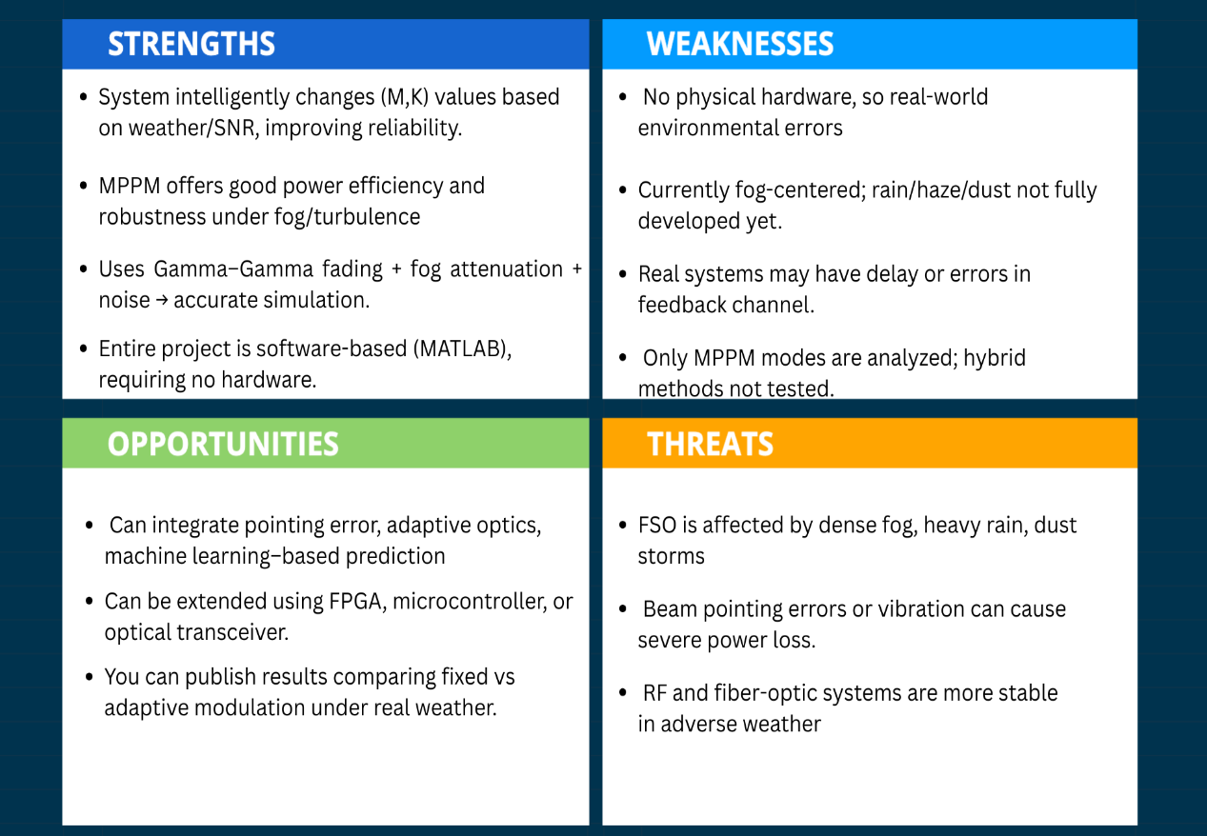

  - Project Plan - GANTT Chart


  - Problem statement

Free Space Optical (FSO) communication systems offer high data rates and low deployment costs but suffer significant performance degradation under atmospheric disturbances such as fog, haze, rain, and turbulence. These weather conditions cause severe attenuation, random power fading, and reduced signal-to-noise ratio (SNR), leading to increased bit-error rate (BER) and unreliable communication. Traditional fixed modulation schemes are not capable of adjusting to rapidly changing channel conditions, resulting in poor throughput and system inefficiency. Therefore, there is a need for an adaptive modulation technique that can dynamically adjust transmission parameters based on real-time channel quality to maintain reliable communication. This project aims to develop and simulate an adaptive Multi-Pulse Pulse Position Modulation (MPPM)-based FSO system in MATLAB that monitors SNR/visibility and automatically switches to the most suitable (M,K) modulation mode to optimize BER, throughput, and link reliability under varying weather conditions.
Chapter 4 : Methodology

  - Description of the approach

The methodology of this project involves developing a complete simulation framework for an adaptive Free Space Optical (FSO) communication system using Multi-Pulse Position Modulation (MPPM). The process begins with generating random binary data and encoding it into MPPM symbols using a fixed combination of M time slots and K pulses. A realistic FSO channel is then modeled by incorporating fog-based attenuation using the Beer–Lambert Law and atmospheric turbulence using the Gamma–Gamma fading model, along with additive Gaussian noise to simulate receiver impairments. The received signal is demodulated to recover the original bits, and BER is calculated to analyze channel performance under different visibility conditions. To enable adaptability, an adaptive modulation algorithm is implemented, allowing the system to dynamically switch MPPM parameters (M, K) based on either visibility thresholds or estimated SNR feedback. Finally, fixed and adaptive schemes are compared using BER and throughput plots across varying weather conditions to evaluate how adaptive modulation improves link reliability and efficiency.

  - Tools and techniques utilized

To implement and test the system, the following tools and techniques were used:

- Simulation Software: MATLAB
- FSO Channel models ;

- Beer–Lambert Law for atmospheric attenuation under fog/haze conditions
- Gamma–Gamma Fading Model for turbulence simulation.
- AWGN (Additive White Gaussian Noise) for modeling receiver and environmental noise

- MATLAB plotting functions such as plot, semilogy, subplot, and xlabel/ylabel were used to visualize BER vs Visibility, throughput graphs, fading distributions, and adaptive switching behavior.
- MATLAB functions like rand, randn, nchoosek, log2, var, and mean were used to generate random bits, noise, symbol combinations, and to estimate SNR and BER

  - Design considerations

The design of the adaptive FSO communication system required careful consideration of several factors that significantly affect system performance. First, the modulation scheme had to balance data rate and robustness, which led to selecting Multi-Pulse Position Modulation (MPPM) due to its flexibility in adjusting M and K. The channel model was designed using Beer–Lambert Law to accurately represent fog attenuation and Gamma–Gamma fading to capture atmospheric turbulence, ensuring realistic simulation of varying weather conditions. Noise modeling using AWGN was also included to represent receiver and environmental noise. Adaptive switching thresholds for M and K were chosen based on visibility and SNR levels to ensure reliable communication during poor weather while maximizing throughput during clear conditions.
Chapter 5 : Implementation

  - Description of how the project was executed
This project was executed through a systematic, simulation-based approach using MATLAB. The development was carried out in multiple stages to ensure correctness, realism, and adaptability of the Free Space Optical (FSO) link under varying weather conditions.
First, random binary data was generated to represent the information to be transmitted. This data was encoded using Multi-Pulse Pulse Position Modulation (MPPM) by developing custom MATLAB functions for modulation and demodulation, where the bits were grouped into symbols and mapped into pulse patterns based on selected parameters (M and K). To validate correctness, the system was initially tested without any channel impairments, ensuring the bit-error-rate (BER) was zero
Next, a detailed atmospheric channel model was created. Fog attenuation was implemented using the Beer–Lambert Law, while atmospheric turbulence was modeled using the Gamma–Gamma fading model, supported by Additive White Gaussian Noise (AWGN). These models allowed the simulation to mimic realistic FSO conditions, including intensity fluctuations, attenuation, and random power fading. The received symbols were analyzed, and BER was calculated for different visibility values to understand how weather impacts the communication link.
Finally, performance analysis was conducted by plotting BER vs Visibility, SNR per frame, Throughput per frame, and Adaptive mode switching. These results demonstrated how the system responded to changing atmospheric conditions and confirmed that adaptive MPPM significantly improves link reliability.

  - Challenges faced and solutions implemented

During the execution of this project, several technical and practical challenges were encountered. One major difficulty was implementing the MPPM modulator and demodulator correctly in MATLAB, as converting bit groups into symbol combinations and ensuring accurate reverse mapping required careful design and debugging. Modeling the FSO channel also presented challenges, especially when integrating fog attenuation using the Beer–Lambert law and simulating atmospheric turbulence using the Gamma–Gamma fading model, which often produced unstable or extreme values. Maintaining proper synchronization between bits, symbols, and frames was another challenge, as even small indexing or size mismatches caused errors during BER computation. Designing the adaptive modulation algorithm required determining appropriate SNR and visibility thresholds to switch between different MPPM modes without causing excessive or unstable switching. Additionally, achieving stable BER and throughput results required running large simulations, which increased computational load and execution time. Debugging MATLAB errors—such as dimension mismatches, missing function arguments, and noise/fading inconsistencies—also demanded significant attention. Overall, overcoming these challenges helped refine the system and improved both the accuracy and reliability of the adaptive FSO communication model.
Chapter 6: Results

  - Outcomes

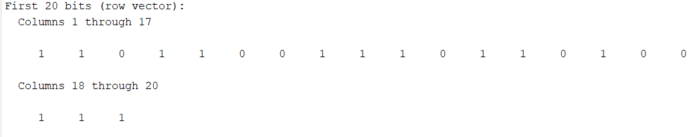

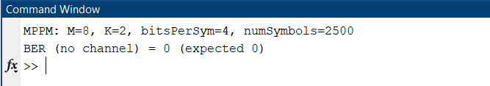

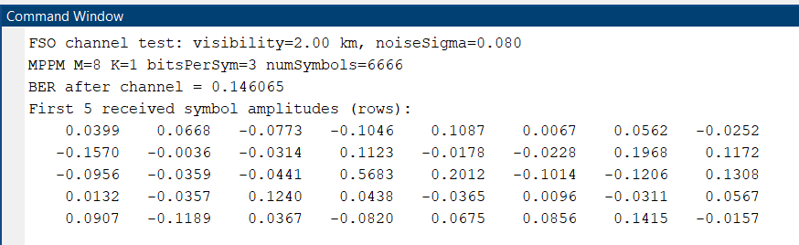

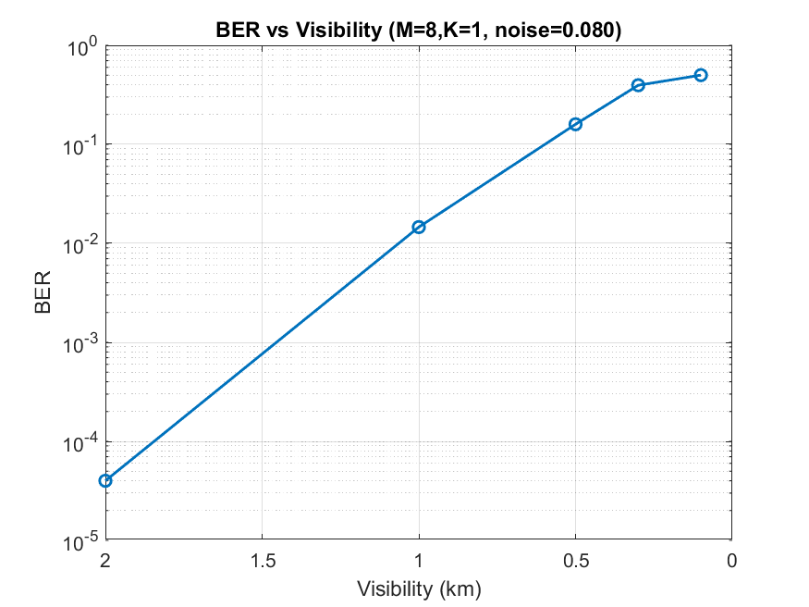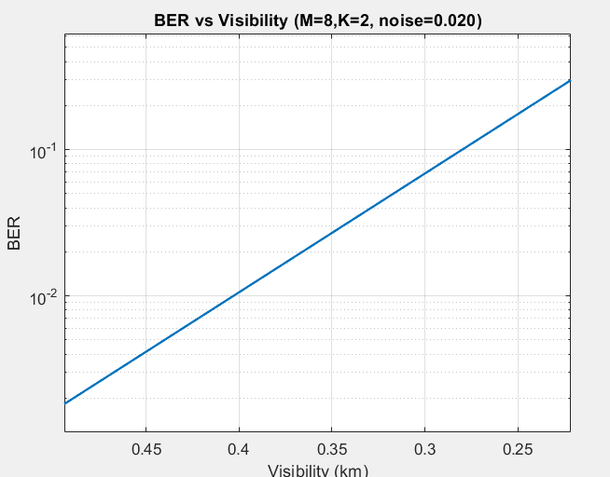



  - Interpretation of results

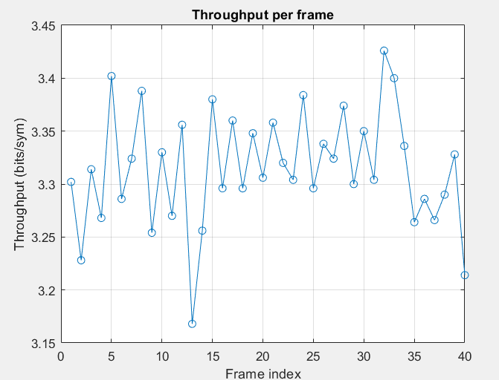
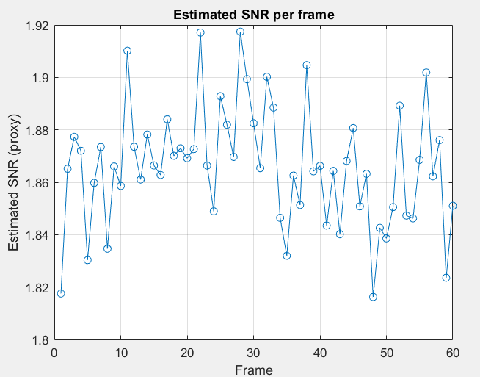

  - Comparison with existing literature or technologies

- Adaptive Modulation (your policy) vs SNR-based/ML adaptation in literature
- Simple rule-based SNR/visibility policies (common in many studies) are easy and explainable — this is what you implemented.
- ML-based policies (recent papers) can learn optimal switching boundaries and account for delays/noisy feedback.
Trade-off: ML methods can outperform rules but need training data, more compute, and risk overfitting.
Takeaway: your approach is practical and low-complexity; an ML-enhanced policy is a natural next step (future work).

2) Channel Modeling: Beer–Lambert + Gamma–Gamma (your work) vs alternatives
- Your choice (Beer–Lambert for attenuation + Gamma–Gamma for turbulence) matches standard academic practice (Andrews & Phillips, Majumdar, Kim).
- Alternatives: log-normal (weak turbulence), Markov models for visibility dynamics, or empirically measured Cn² profiles.
Trade-off: Gamma–Gamma covers weak→strong turbulence better; log-normal is simpler but less general.

Chapter 7: Conclusion

Up to this stage of the project, a complete simulation framework for an FSO communication system using Multi-Pulse Position Modulation (MPPM) has been successfully developed. Random bit generation, MPPM modulation, and demodulation were implemented and verified to work accurately under ideal conditions. A realistic FSO channel model incorporating fog attenuation using the Beer–Lambert Law, additive Gaussian noise, and atmospheric turbulence using the Gamma–Gamma model was designed to analyze system behavior under different weather conditions. BER vs Visibility results clearly show that signal quality deteriorates as visibility decreases, matching real FSO characteristics. An adaptive modulation mechanism was introduced to dynamically adjust MPPM parameters (M, K) based on visibility or SNR conditions, improving robustness during fog and enhancing data rate in clear weather. Initial comparisons between fixed and adaptive schemes demonstrate that adaptive modulation provides significantly better BER and throughput performance in varying atmospheric conditions. Overall, the system is functioning correctly, and the core adaptive concept has been validated, forming a strong foundation for the remaining stages of the project.
Chapter 8 : Future Work

Future work will focus on extending and refining the adaptive FSO system to make it more accurate, intelligent, and realistic. Additional atmospheric conditions such as rain, haze, dust, and smoke can be included to broaden the channel model beyond fog. The adaptive modulation algorithm can be improved by combining visibility and SNR feedback and by optimizing switching thresholds using machine learning or data-driven methods. More advanced turbulence models, such as pointing error, beam wander, or log-normal–gamma hybrid fading, can be added to better represent practical FSO scenarios.

References
- H. Willebrand and B. S. Ghuman, Free Space Optics: Enabling Optical Connectivity in Today’s Networks. Sams Publishing, 2002.

- A.K. Majumdar and J. C. Ricklin, Free-Space Laser Communications: Principles and Advances. Springer, 2008.

- Z. Ghassemlooy, W. Popoola, and S. Rajbhandari, Optical Wireless Communications: System and Channel Modelling with MATLAB. CRC Press, 2017.

- I. I. Kim, B. McArthur, and E. Korevaar, “Comparison of laser beam attenuation models for terrestrial free-space optics links,” Proc. SPIE, vol. 4530, pp. 20–31, 2001.

- H. Kaushal and G. Kaddoum, “Optical Communication in Space: Challenges and Mitigation Techniques,” IEEE Commun. Surveys Tuts., vol. 19, no. 1, pp. 57–96, 2017.

- M. Uysal, C. Capsoni, Z. Ghassemlooy, A. Boucouvalas, and E. Udvary, Optical Wireless Communications: An Emerging Technology. Springer, 2016.

- Y. Wang et al., “Performance analysis of an adaptive optics system for free-space optics communication through atmospheric turbulence,” Google Scholar, 2023.








Bengaluru City Office No 5/1, First Floor, Prestige Terraces, Union Street, Infantry Road, Bengaluru - 560003 Karnataka, India

GIMSR
GITAM Medical College Rd, Gandhi Nagar, Rushikonda, Visakhapatnam - 530045 Andhra Pradesh, India

